WEEK 6

1BM21CS244

use cs244_emp_id;

insert into employee values(11,'zampa',11,'2012-10-15',400000,200);

QUERY 1

select emp_name from employee where emp_no in (select mgr_no from employee group by

mgr_no having count(emp_no)=( select count(emp_no) from employee group by mgr_no order by count(emp_no) desc limit 1));

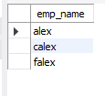

QUERY 2

select a.emp_name from employee a where a.sal > (select avg(e.sal) from employee e where e.mgr_no=a.emp_no group by e.mgr_no);



QUERY 3

select emp_name from employee where emp_no in (select distinct mgr_no from employee where emp_no in (select distinct mgr_no from employee ));

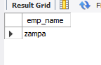

QUERY 4

select * from employee where emp_no =( select emp_no from incentives where incentive_date between '2019-01-01' and '2019-01-31'

and incentive_amt!=(select max(incentive_amt) from incentives where incentive_date between '2019-01-01' and '2019-01-31'));

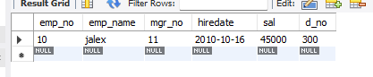

QUERY 5

select e.emp_name from employee1 e where e.d_no=(select d_no from employee where e.mgr_no=emp_no);

